Final Report: CMRF Project Grant

Project Title: Screening for Potent Inhibitors of Myeloperoxidase
Principal Investigator: Dr Louisa Forbes
Department: Centre for Free Radical Research, Department of Pathology
University of Otago, Christchurch.
CMRF Ref: 14/09

Research
Overall project objective: To develop a unique high throughput screening assay for the identification of new inhibitors of the haem enzyme myeloperoxidase.
Results: The project progressed very well over the year of funding. I will use the project aims to detail the work that was carried out.

- Design a unique screening assay for MPO that is based on our existing robust stand-alone assays but uses conditions that address the short-comings of current screens.

This was achieved. I was able to take advantage of special features of a relatively new automated plate reader machine in our research group. It has the function of being able to inject the final activating reagent into the assay, mix the solution, and then capture the very beginning of the reaction that is initiated.

- Test the new assay against known fully characterised inhibitors to check that it finds both reversible and irreversible inhibitors but is not prone to excessive false positives.
Testing was extensive and integral to developing the system into the most robust tool possible. Figure 1 shows the kinetic readout of the new assay and the performance of known potent inhibitors added to the system. The green line is the loss over time of absorbance at 412nm in the full reaction system, indicating full activity of the enzyme myeloperoxidase. The slope of the line is the reaction rate and depends on the presence of other reagents added to the reaction which had been carefully optimised. As a negative control, the omission of myeloperoxidase gives the dark blue line with negligible slope, which shows that the reaction the assay measures is indeed due to myeloperoxidase.
The other coloured lines show the effect of including different test compounds into the reaction system. Two known potent inhibitors of myeloperoxidase, HX1 and TX1, were used as positive controls to prove that the assay can detect inhibition of myeloperoxidase by reversible and irreversible mechanisms. The mid-blue line shows that good inhibition (a much shallower slope) is achieved by para-bromoaniline, whereas the same amount of para-nitroaniline (orange line) shows no effect on the rate of reaction. This is a most important result, because para-nitroaniline is a false positive when tested in other routine assays widely used to measure inhibition of myeloperoxidase, as in Figure 2.
Figure 2 shows the two aniline compounds as tested in a regular system that measures an activity endpoint rather than a rate. The para-bromoaniline is clearly a strong inhibitor of myeloperoxidase but para-nitroaniline also inhibits quite well in this system. The dotted line indicates that 5µM para-nitroaniline can achieve about half the inhibition of 5µM para-bromoaniline. This assay however, has minimal reagents in the test solution causing the catalytic cycling of the enzyme to be limited and rather artificial. Inhibition of myeloperoxidase is easier to achieve in this standard assay, but from more rigorous testing we know that inhibition by para-nitroaniline should be regarded as a false positive. The fact that the new assay in Figure 1 does not detect inhibition by para-nitroaniline, demonstrates the elimination of such false positives. We have designed the new assay conditions to better mimic the physiological environment of myeloperoxidase than previous systems, making it more discriminating and only detecting the best candidates as inhibitory compounds.

Figure 1. New assay for measuring inhibition of myeloperoxidase
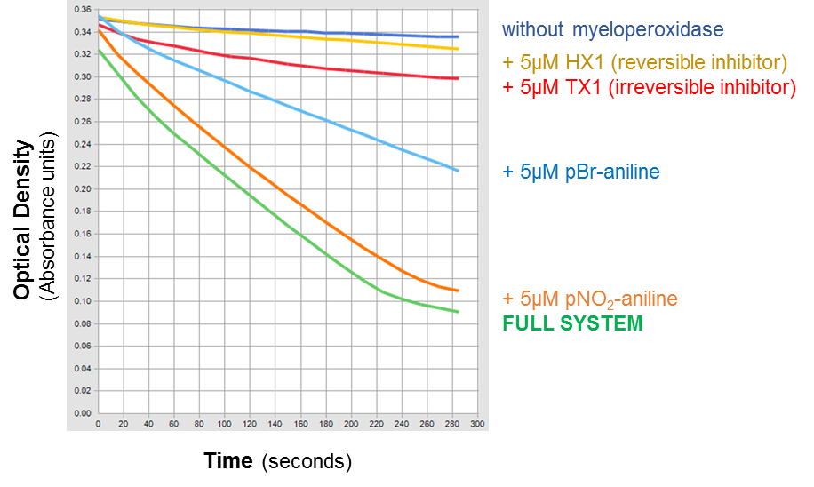

Figure 2. Standard inhibition assay (Taurine chloramine with tyrosine)
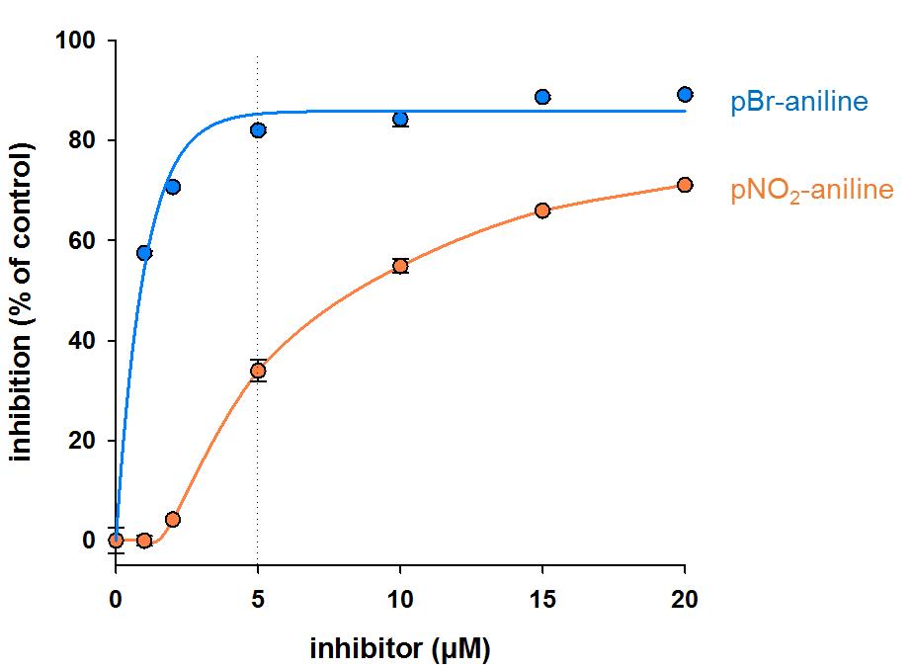

3. Deploy the new assay as a screening tool against a selection of potential inhibitors and a chemical library of unknown compounds.
The assay is suitable for screening collections of compounds. We have used it to test various compounds of interest in our research group, including compounds known to inhibit other enzymes. This work is ongoing and the assay has proven to be both sensitive and selective, providing invaluable results. A new international collaboration has been entered into since developing the assay, with researchers in the Czech Republic. They sent us a panel of compounds shortlisted for interest in their own research, and I screened them for their ability to inhibit myeloperoxidase. The collaborators are currently using these results to develop a new library of compounds for further testing. This will eventually be written up as a joint publication.

4. Determine the mechanism of inhibition of the new potent inhibitors.
I am writing a review with Prof Tony Kettle on inhibitors of myeloperoxidase and their mechanisms. The new assay and our results from using it to date have been key to our summation of research into myeloperoxidase inhibition. The new assay provides insights into how inhibitory compounds interact with the enzyme. We also have another publication in preparation directly resulting from specific results using the new assay. In this paper we describe the mechanism by which indole and aniline compounds inhibit myeloperoxidase.

5. Commercialize our assay for inhibitors of MPO.
Our viewpoint on this has changed a little. Rather than designing an assay package for commercialization, we will publish the assay in the scientific press as it provides such a useful research tool for this area of study. This is in the indole and aniline paper mentioned above. We will continue to undertake collaborations with other research groups, but we are trialling a screening programme that in future we will offer as a paid service. The new assay is the key step in the inhibitor screen, and our publication will demonstrate the strengths it has over existing assay systems.

Funding body specific outcomes
The CMRF was established to support medical research in Canterbury, with the aim of having both local and global impact. This project has been successful in meeting these objectives. With this funding, we have been able to use our existing expertise and technical base to produce a new research tool in our area of biomedical research. The new assay will help in the discovery of inhibitors of myeloperoxidase, which would be of great value for the treatment of inflammatory diseases.

Key findings
- development of a unique screening assay for inhibitors of myeloperoxidase
- proof of suitability as a screening tool by use in an international collaboration
- application of the assay to determine inhibitory mechanisms of selected compounds
- preparation of review manuscript on the field of inhibitors of myeloperoxidase, and an original article detailing the new assay

Publications
Presentations:
International conference: 7-10th December 2015, Christchurch, New Zealand.
Seventh Joint Meeting of the Societies for Free Radical Research, Australasia and Japan
Oral presentation “Strategies for inhibiting myeloperoxidase and limiting oxidative stress during inflammation”

Department symposium: 31st March/1st April 2016, Department of Pathology, University of Otago, Christchurch.
Oral presentation “Aspirin – hidden talents of an old favourite”

Written report for collaborator: Eugenie Nepovimová, Biomedical Research Centre, University Hospital Hradec Kralove, Czech Republic
Emailed 23 June 2016 “Report on screening tacrine-thiaquinazolinone hybrid compounds
for the inhibition of myeloperoxidase”

Scientific press publications:
In preparation: an invited review for the journal Pharmacology and Therapeutics
“Strategies for Inhibiting Myeloperoxidase and Limiting Oxidative Stress During Inflammation” by L.V. Forbes and A.J. Kettle.

In preparation: original research article for publication of the new assay for inhibitors of myeloperoxidase together with analysis of the inhibitory mechanism of indole and aniline compounds.

